EVENT FORCE MANAGEMENT SYSTEM

1. Introduction
The Event Force Management System is a web-based application developed to simplify and organize the management of workforce involved in various events. Organizing an event requires proper coordination between event managers, staff members, volunteers, security personnel, technical teams, and other supporting members. Managing all these people manually can be difficult and may lead to errors, delays, and communication problems.
The proposed system provides a centralized platform where administrators can create and manage events, register workforce members, assign staff to events, allocate tasks, monitor attendance, and track the progress of activities.
The system is designed to reduce manual work and improve the efficiency of event workforce management. Instead of maintaining staff details and event information using paper records or separate spreadsheets, all information can be stored and managed digitally.
The application can be useful for college events, conferences, exhibitions, cultural programs, sports events, corporate events, workshops, and other large-scale programs.

Main Objectives
- To provide a centralized system for managing event workforce.
- To maintain event and staff information digitally.
- To assign suitable staff members to specific events.
- To manage and track event-related tasks.
- To monitor workforce attendance.
- To reduce manual work and human errors.
- To improve coordination between event managers and staff.
- To provide a simple dashboard for monitoring event activities.

Problem Statement
In traditional event management, workforce details are often maintained using paper records, spreadsheets, phone calls, or messaging applications. When the number of events and staff members increases, managing this information becomes difficult.
Some of the major problems in the existing approach are:
- Staff information may not be properly organized.
- Checking staff availability takes time.
- Assigning staff to events manually can result in conflicts.
- Tasks may not be properly tracked.
- Attendance records may be difficult to maintain.

Proposed System
The Event Force Management System solves these problems by providing a centralized web application.
The administrator can create an event and enter important information such as event name, date, time, venue, and required workforce. Staff members can be registered with their personal information, roles, skills, and availability.
Based on the event requirements, available workforce members can be assigned to specific events. Tasks can also be created and assigned to individual staff members. Their task status can be updated as Pending, In Progress, or Completed.
The system can also maintain attendance information and provide dashboard statistics for easy monitoring.

Advantages of the Proposed System
- Centralized data management.
- Easy workforce allocation.
- Faster event management.
- Better task tracking.
- Easy attendance monitoring.

3.1 Admin Module
The Admin Module is the main control module of the application. The administrator can manage events, workforce members, tasks, and attendance.

Features
- Admin login.
- Add and manage events.
- Add and manage workforce members.
- Assign workforce to events.
- Create and assign tasks.
- Monitor attendance.

3.2 Event Management Module
This module is used to create and manage event information.
The administrator can enter:
- Event name.
- Event description.
- Event date.
- Start and end time.
- Venue.
- Event type.
- Required workforce.
- Event status.

3.3 Workforce Management Module
This module manages all employees, volunteers, coordinators, security personnel, technicians, and other event staff.
The system can store:
- Staff ID.
- Name.
- Email.
- Phone number.
- Role.
- Skills.
- Experience.

3.4 Workforce Allocation Module
This module helps administrators assign workforce members to particular events.
For example, a college cultural event may require:
- Event Coordinators.
- Volunteers.
- Security Staff.
- Technical Staff.
- Medical Support Staff.
The administrator can check the available workforce and assign appropriate members according to their role and skills.

3.5 Task Management Module
The Task Management Module is used to create and monitor event-related responsibilities.
A task can contain:
- Task name.
- Task description.
- Event name.
- Assigned staff.
- Priority.

3.6 Attendance Module
The Attendance Module is used to maintain workforce attendance during events.
The system can record:
- Staff name.
- Event name.
- Date.
- Check-in time.
- Check-out time.
- Attendance status.
Attendance status can include:
- Present
- Absent
- Late
- On Leave
This feature makes attendance management easier and reduces the need for manual attendance records.

3.7 Dashboard Module
The dashboard provides an overview of the complete system.
It can display:
- Total events.
- Upcoming events.
- Ongoing events.
- Completed events.
- Total workforce.
- Available workforce.
- Assigned workforce.
- Pending tasks.
- Completed tasks.
- Attendance information.
The dashboard allows administrators to understand the current status of events quickly.

4.1 Technology Stack
The project can be developed using the following technologies:

Frontend
- HTML5 – Used to create the structure of web pages.
- CSS3 – Used for designing and styling the application.
- JavaScript – Used to implement interactive functionality.
- Bootstrap – Can be used to create a responsive user interface.

Backend
- Node.js – Used as the server-side runtime environment.
- Express.js – Used to develop backend APIs and handle HTTP requests.

Database
- MongoDB – Used to store user, event, workforce, task, and attendance information.

Development Tools
- Visual Studio Code
- Git
- GitHub
- Postman

4.2 System Workflow
The basic workflow of the system is:
Admin Login
↓
Create Event
↓
Register Workforce
↓
Check Workforce Availability
↓
Assign Workforce
↓
Create Tasks
↓
Assign Tasks
↓
Record Attendance
↓
Monitor Task Progress
↓
Complete Event
Program phase

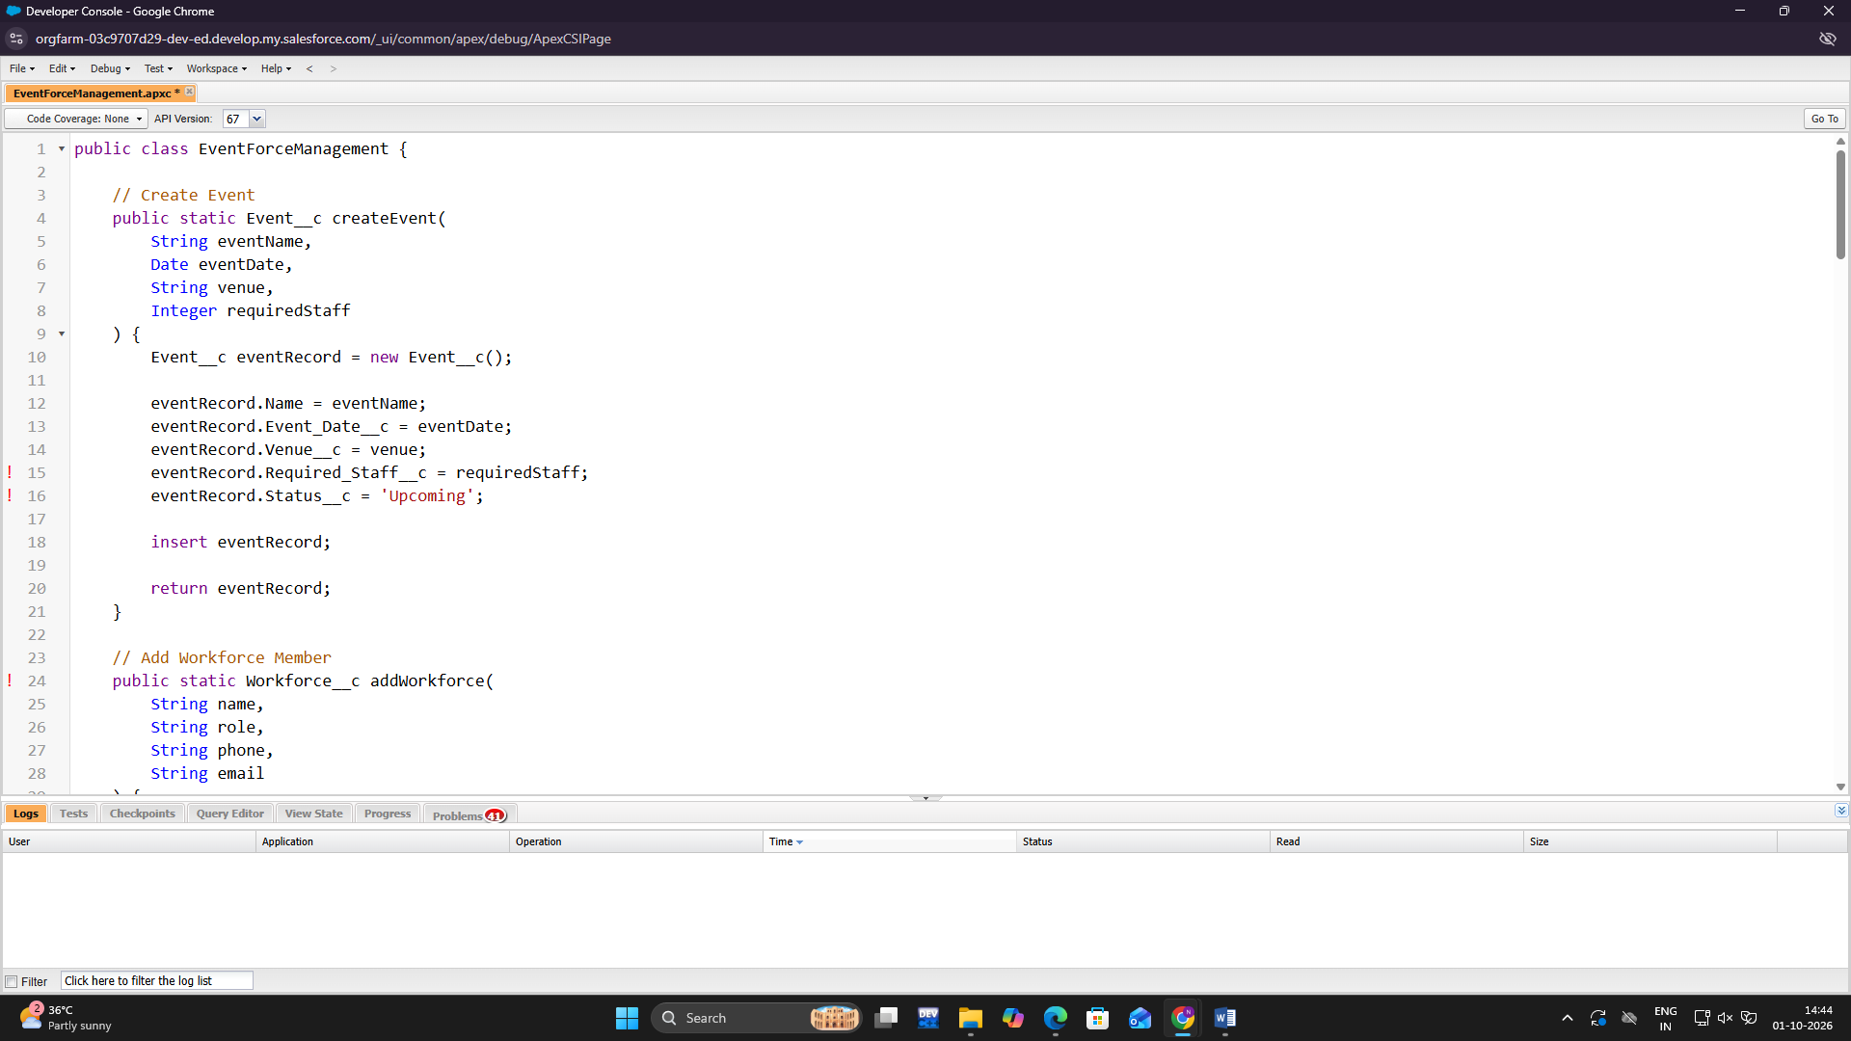
process

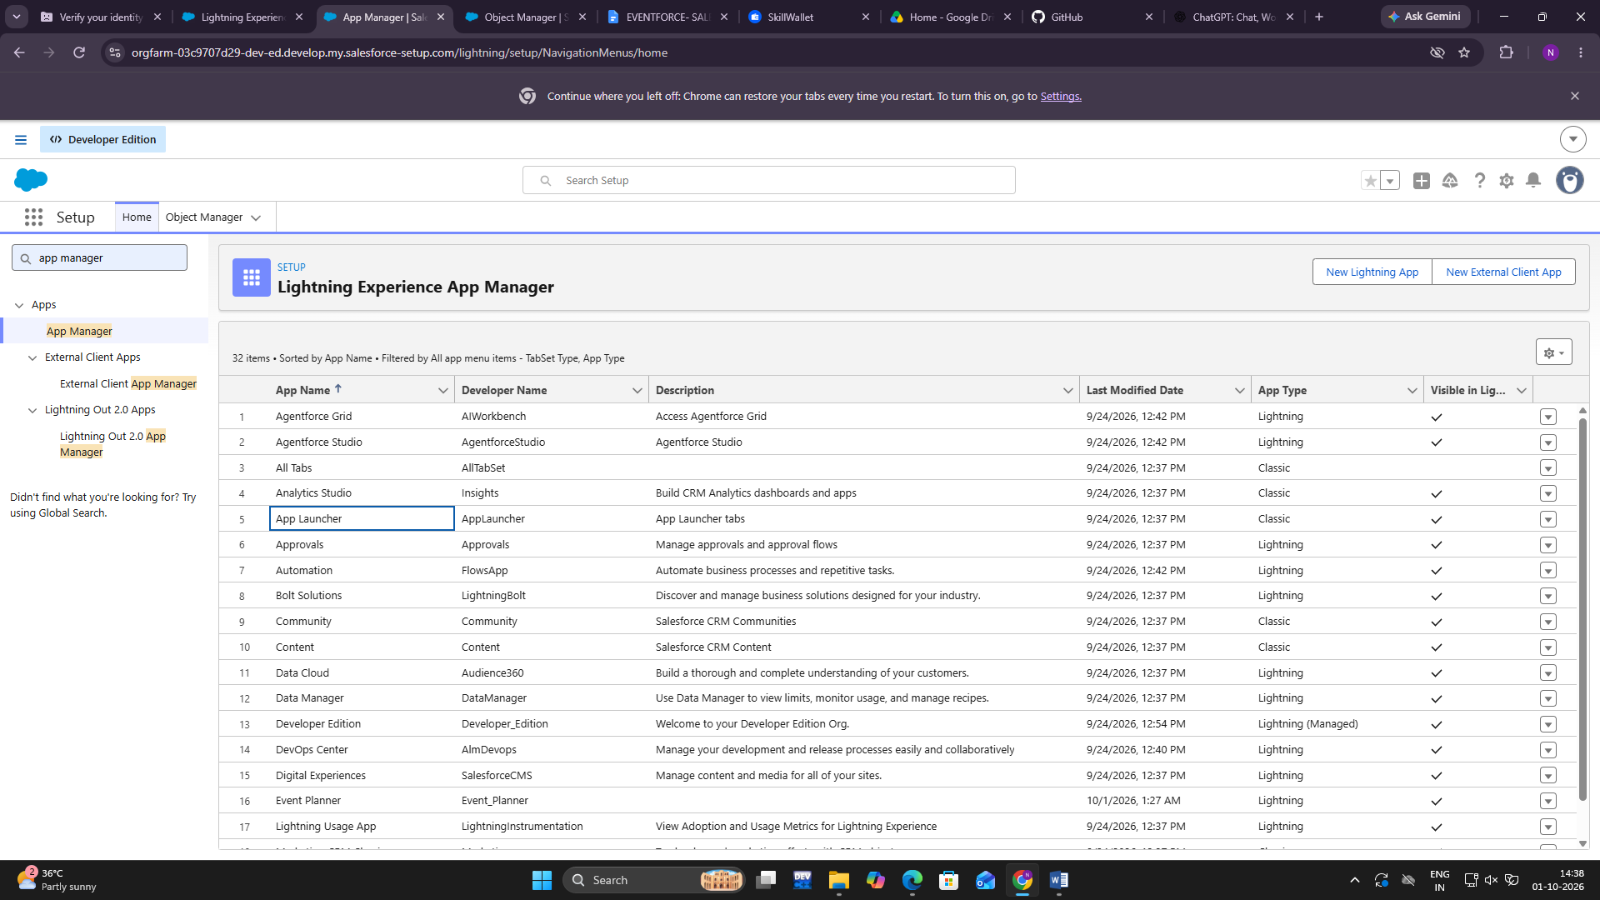

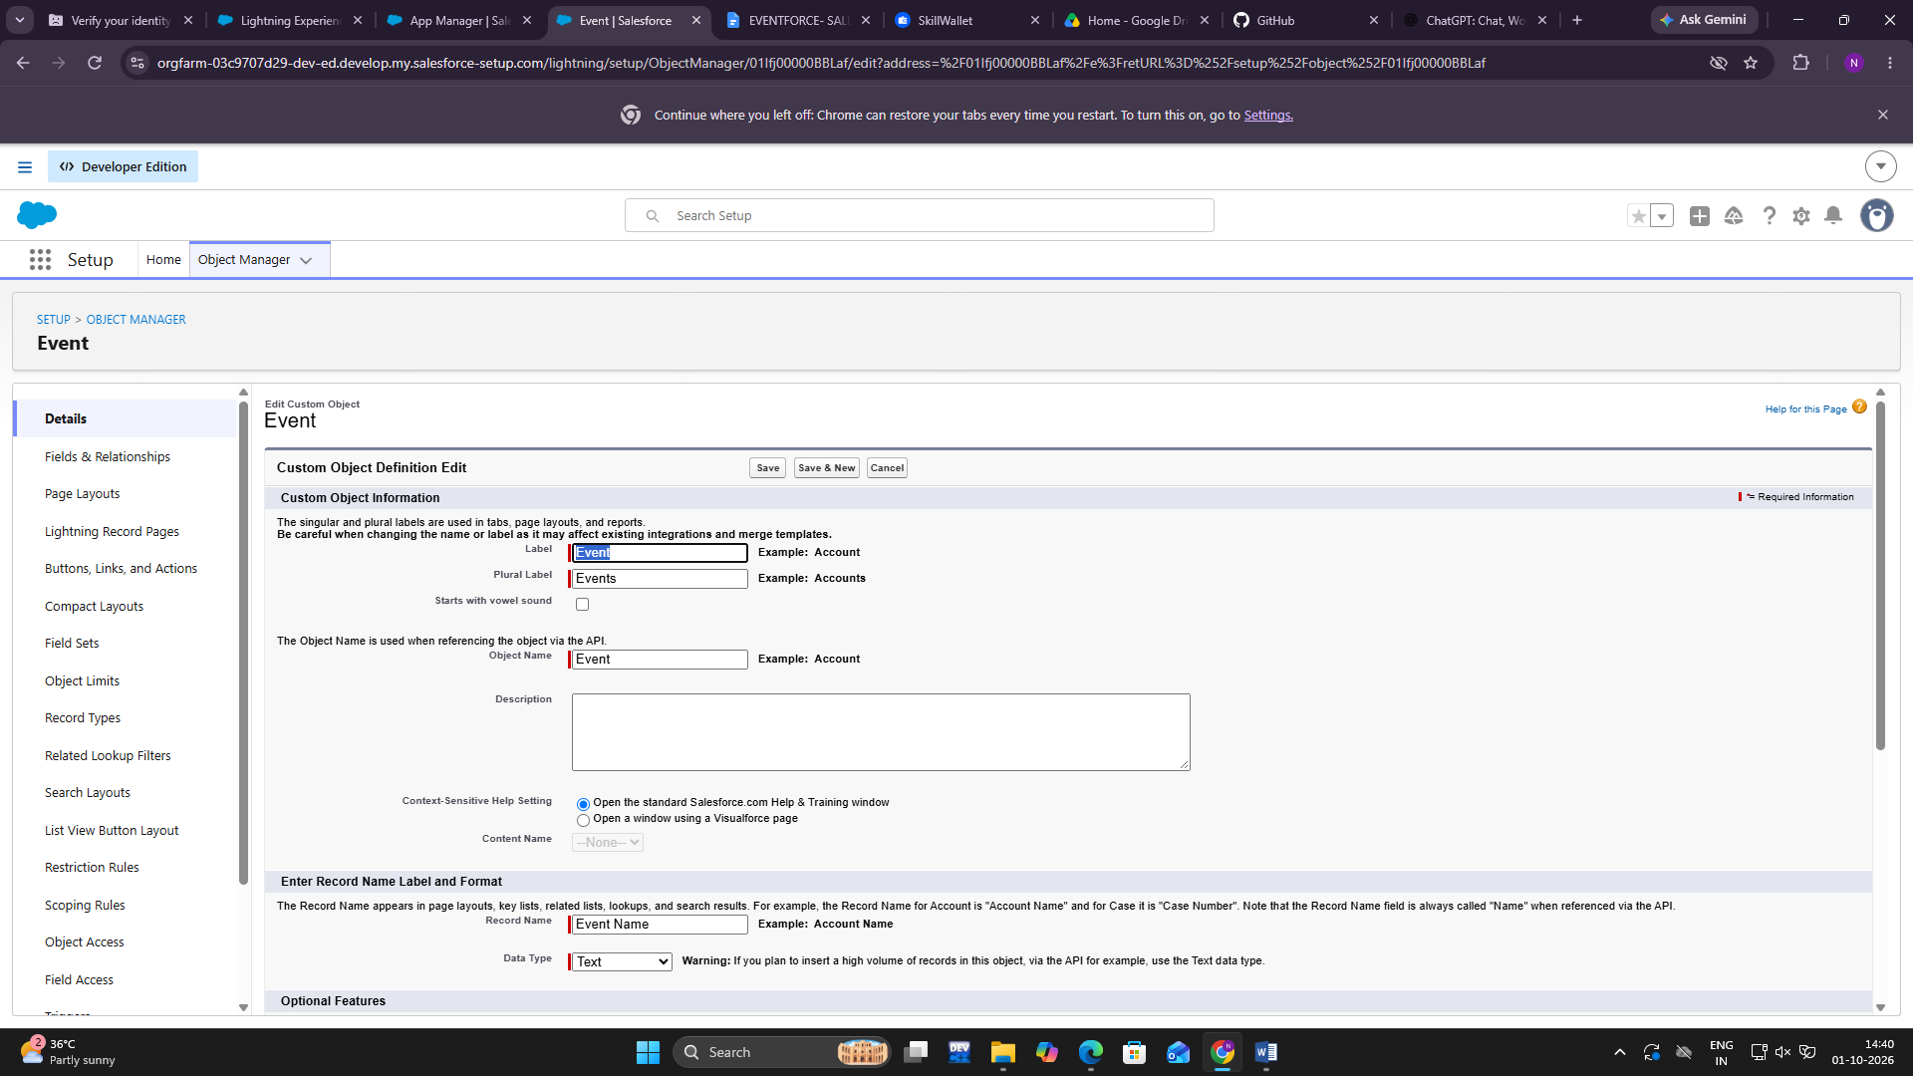

5.1 Benefits
The Event Force Management System provides several benefits to event organizers.

Easy Workforce Management
All workforce information can be stored in one centralized system, making it easy to access and update.

Efficient Staff Allocation
Available workforce members can be assigned to events based on their roles, skills, and availability.

Better Task Monitoring
Event managers can create tasks and track their completion status.

Attendance Tracking
The system provides a structured method for recording workforce attendance.

5.2 Future Enhancements
The system can be further enhanced with additional features.

Mobile Application
A mobile application can be developed so that staff members can access event information and tasks from their smartphones.

QR Code Attendance
QR codes can be used for quick and automated workforce check-in and check-out.

Notification System
Email, SMS, and push notifications can be added to notify staff about new event assignments, tasks, deadlines, and schedule changes.

GPS-Based Features
Location-based features can be introduced for authorized event management purposes.

Advanced Analytics
Charts and graphs can be added to analyze workforce utilization, attendance, task completion, and event performance.

5.3 Conclusion
The Event Force Management System is designed to provide a simple and organized solution for managing workforce involved in events. It combines event management, workforce allocation, task management, attendance tracking, and reporting into a single platform.
The system reduces manual effort and provides administrators with better control over event-related workforce activities. By maintaining information digitally, the application improves data organization, accessibility, and coordination.
Overall, the Event Force Management System provides an effective digital approach for organizing and managing event workforce in a structured and efficient manner.

